Custom Content Outline — 8-PAGE
Fall 2016 — Volume 9, Issue 4 — Breast Cancer Awareness

To our valued magazine customers:
MyHometownHealth has been designed to allow its subscriber hospitals the flexibility to modify or customize as much or as little of the content as desired, in order to create a magazine unique to the hospital and its market.

This Custom Content Outline is designed to help your hospital plan its upcoming issue. This document attempts to identify the portions of the magazine that you might like modified, and to accurately record your hospital’s customized information and instructions. For those subscribers who prefer a more hands-on involvement with the modification and customization of this issue of MyHometownHealth, an interactive template is available through BCI’s proprietary Online Editor. For more information about creating your magazine online, contact lindsay@brentwoodcommunications.com.

The following is a list of editorial content available in the current issue of MyHometownHealth.

Fall 2016 Vol. 9 No. 4 – BREAST CANCER AWARENESS
Cover: Contents: Featured Celebrity – Sheryl Crow
Page 2: Article #1: Celebrity Spotlight – Sheryl Crow, “A Newfound Song of Gratitude”
Pages 2-3: Article #1 Cont.: Celebrity Spotlight – Sheryl Crow, “A Newfound Song of Gratitude”
Page 3: Article #2: CEO Message
Page 4: Article #3: Live it Out
Page 5: Article #4: Breast Cancer – Are You at Risk?
Page 5: Article #5: Women & Osteoporosis
Page 6-7: Article #6: All the Ways We Care
Page 8: Article #7: Breast Cancer by the Numbers
Page 8: Article #8: Maximize your health insurance benefits

Upon completing this Custom Content Outline, please return it to Brentwood Communications, along with all text edits, text documents, custom photography, staff or physician photos and other materials necessary to complete your customized magazine.

The deadline for custom content is Thursday, July 15, 2015. For more information or assistance: call 615-425-0821 or email lindsay@brentwoodcommunications.com.

COVER – PAGE 1

Hospital Name: __________________________________________________________

Please designate a cover photo.
_____ Use recommended cover photo. (shown above)
_____ I will supply a new photo. File name: ___________________________________

*PLEASE NOTE: If you have selected to keep the proposed cover photo, you must also use the proposed cover story.

Please confirm your preference regarding text.
_____ Use current cover text with no changes.
_____ I will submit text edits for the cover. (please attach all edits and modifications)

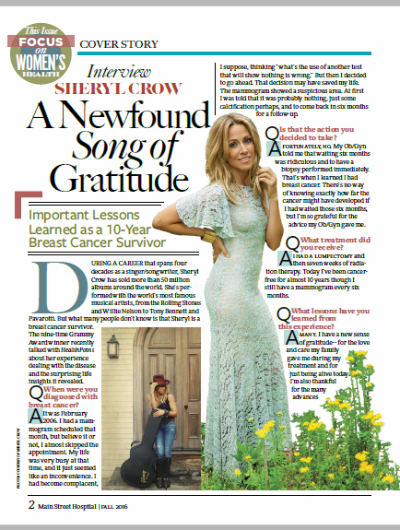

PAGE 2-3 — ARTICLE #1: Celebrity Spotlight – Sheryl Crow

Please confirm your preference regarding text (which continues on page 3).
_____ Use current article with no changes.
_____ Use current article with text edits. (Please attach all edits and modifications)
_____ I will supply a replacement article. File name: ____________________________

PAGE 3 – ARTICLE #2: CEO Message

Please designate a photo preference.
_____ Do NOT use the CEO’s name or photo.
_____ Yes, please include the CEO’s photo. File name: __________________________
_____ Yes, please include the CEO’s name: ___________________________________

Please confirm your preference regarding text.
_____ Use current article with no changes.
_____ Use current article with text edits. (Please attach all edits and modifications)
_____ I will supply a replacement article. File name: ____________________________

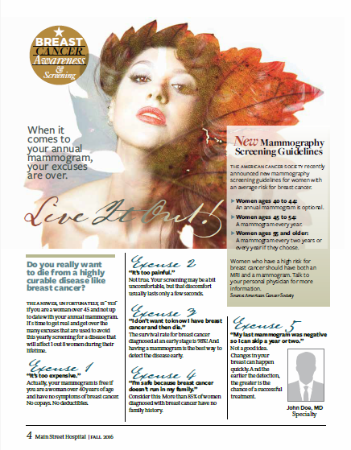

PAGE 4 – ARTICLE #3: Live it Out!

Please designate a physician photo preference.
_____ Do NOT use a physician photo.
_____ Yes, please include a physician photo. File name: _________________________
_____ Yes, please include the physician’s name: ________________________________
_____ Yes, please include the physician’s specialty: _____________________________

Please confirm your preference regarding text.
_____ Use current article with no changes.
_____ Use current article with text edits. (Please attach all edits and modifications)
_____ I will supply a replacement article. File name: ____________________________

Please confirm your choice regarding stock photo(s).
_____ Use current photo(s).
_____ Use my supplied photo(s) (Attach your photo(s) of choice. PLEASE NOTE: Photos should be
300dpi at final reproduction size for best print quality.)
_____ I would like BCI to select an appropriate alternate photo to go with current article.
_____ I would like BCI to select an appropriate alternate photo to go with my custom article.

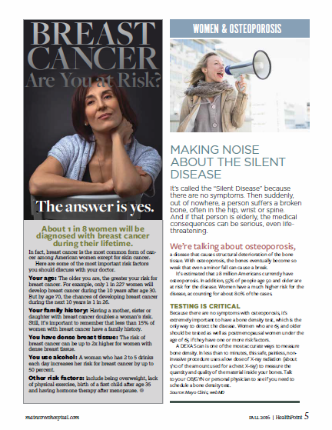

PAGE 5 — ARTICLE #4: Breast Cancer – Are You at Risk?

Please confirm your preference regarding text.
_____ Use current article with no changes.
_____ Use current article with text edits. (Please attach all edits and modifications)
_____ I will supply a replacement article. File name: ____________________________

Please confirm your choice regarding stock photo(s).
_____ Use current photo(s).
_____ Use my supplied photo(s) (Attach your photo(s) of choice. PLEASE NOTE: Photos should be
300dpi at final reproduction size for best print quality.)
_____ I would like BCI to select an appropriate alternate photo to go with current article.
_____ I would like BCI to select an appropriate alternate photo to go with my custom article.

PAGE 5 — ARTICLE #5: Women & Osteoporosis

Please confirm your preference regarding text.
_____ Use current article with no changes.
_____ Use current article with text edits. (Please attach all edits and modifications)
_____ I will supply a replacement article. File name: ____________________________

Please confirm your choice regarding stock photo(s).
_____ Use current photo(s).
_____ Use my supplied photo(s) (Attach your photo(s) of choice. PLEASE NOTE: Photos should be
300dpi at final reproduction size for best print quality.)
_____ I would like BCI to select an appropriate alternate photo to go with current article.
_____ I would like BCI to select an appropriate alternate photo to go with my custom article.

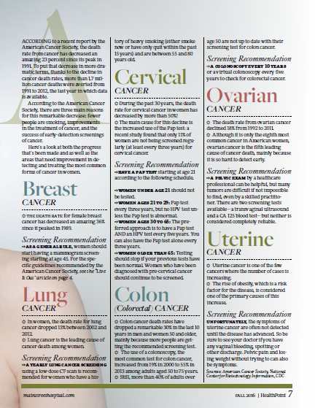

PAGE 6-7 – ARTICLE #6: All the Ways We Care

Please confirm your preference regarding text.
_____ Use current article with no changes.
_____ Use current article with text edits. (Please attach all edits and modifications)
_____ I will supply a replacement article. File name: ____________________________

Please confirm your choice regarding stock photo(s).
_____ Use current photo(s).
_____ Use my supplied photo(s) (Attach your photo(s) of choice. PLEASE NOTE: Photos should be
300dpi at final reproduction size for best print quality.)
_____ I would like BCI to select an appropriate alternate photo to go with current article.
_____ I would like BCI to select an appropriate alternate photo to go with my custom article.

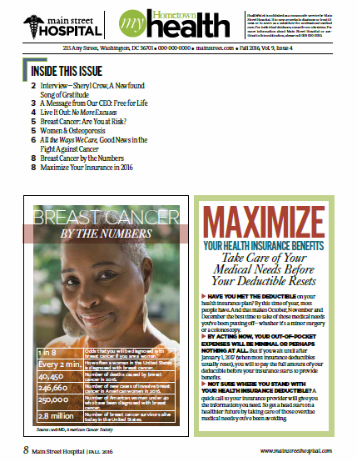

PAGE 8 – ARTICLE #7: Breast Cancer by the Numbers

Please confirm your preference regarding text.
_____ Use current article with no changes.
_____ Use current article with text edits. (Please attach all edits and modifications)
_____ I will supply a replacement article. File name: ____________________________

Please confirm your choice regarding stock photo(s).
_____ Use current photo(s).
_____ Use my supplied photo(s) (Attach your photo(s) of choice. PLEASE NOTE: Photos should be
300dpi at final reproduction size for best print quality.)
_____ I would like BCI to select an appropriate alternate photo to go with current article.
_____ I would like BCI to select an appropriate alternate photo to go with my custom article.

PAGE 8 – ARTICLE #8: Maximize your health insurance benefits

Please confirm your preference regarding text.
_____ Use current article with no changes.
_____ Use current article with text edits. (Please attach all edits and modifications)
_____ I will supply a replacement article. File name: ____________________________

Please confirm your choice regarding stock photo(s).
_____ Use current photo(s).
_____ Use my supplied photo(s) (Attach your photo(s) of choice. PLEASE NOTE: Photos should be
300dpi at final reproduction size for best print quality.)
_____ I would like BCI to select an appropriate alternate photo to go with current article.
_____ I would like BCI to select an appropriate alternate photo to go with my custom article.

